**Design Document for the game: Twisting Fate (W.T.)**

# 

**Game Loop** **2**

**Mechanics** **3**

**Art Style** **4**

**Technical Design** **5**

**Level/Game Design** **6**

**Story Design** **7**

# 

### Game Loop

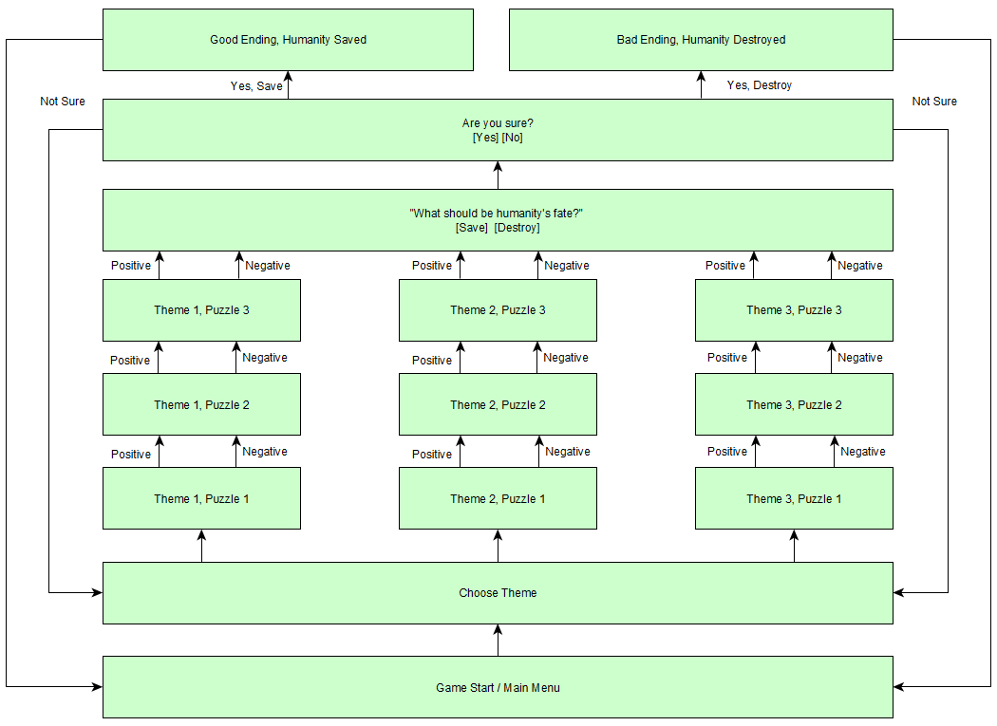

* The game starts by giving the player a choice of a Theme, and all puzzles that the player goes through after this choice will revolve around said theme.
* Each puzzle has two solutions, positive and negative.
  + Solving the puzzles in a positive or negative way affects the game narrative and visuals to a certain extent.
* After going through all the puzzles for the specific theme - the user is put in front of a choice whether humanity should be saved or destroyed.
  + See Level/Game Design for more context on why this choice is presented.
* The player is asked if he/she is sure about the choice made.
  + If sure - player reaches one of the endings based on the choice.
  + If not sure - player is redirected to the Theme choice screen, to either explore puzzles under different Themes or try to get more positive or negative solutions in previously explored Themes.

### Mechanics

* Mouse only
  + Right click - Move to direction
  + Left-Click - Jump

### Art Style

* **Tools:** Inkscape
* **Theme:** Sci-fi 2D style
* **Color Palette:** Dark Blue, Gray, White, Black
* **Background:** Solid
* **Levels:**
* **Music:** Retro, Ambient, Sci-fi

Ending Scene Art Ideas/ Comic book Ending: 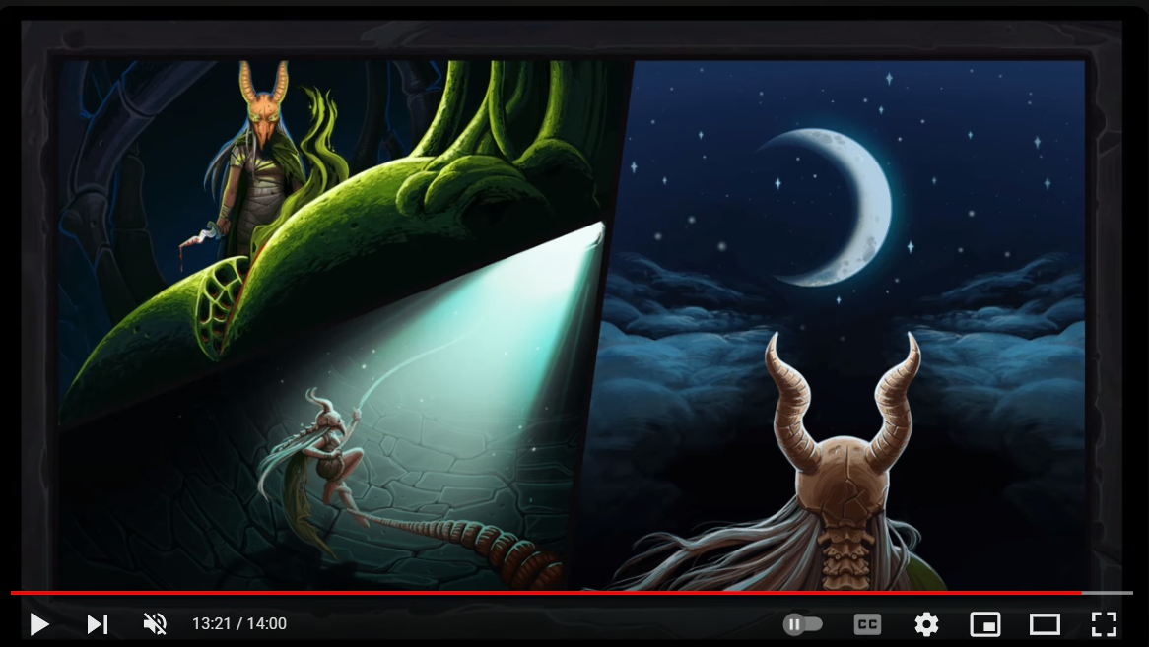

https://youtu.be/fmIaHAtabSU

### **Technical Design**

* Engine: Unity 2022.3.16f1 LTS
* Coding: C#
* Tools:
  + Github desktop
  + Inkscape
  + Visual Studio 2019, VSCode
  + Ableton Live
    - https://www.ableton.com/
  + Audacity
  + WED
  + Trello
    - Link: <https://trello.com/invite/b/nR9PUJ22/ATTI1ef4f9f2c13bb7bc40672449c3805eba33527032/twisted-fate>

### 

### 

### 

### Level/Game Design

* At the start of a game, the player is presented with a choice of a Theme, which is generally something negative. (e.g. War)
* Each playable level is represented by a puzzle.
* At the start of the level, the player is presented with a Theme-based piece of technically truthful information in the form of a statement or a question.
  + E.g. “Did you know? There are no periods in human history completely without wars.”
* Each level is designed with the general Theme and level-related information in mind.
* Each level has two solutions:
  + A positive solution represents the player's resistance against the previously presented information, trying to find a hopeful counter-argument to it.
    - E.g. “But the amount of wars and deaths have been decreasing over time. It’s a slow process, but the progress towards peace is there.”
  + A negative solution represents the player’s acknowledgement of the original information, or a failure to find a counter-argument.
* The puzzles and game narrative try to form an image of the world for the player, which should affect the player's choice if humanity should be saved or destroyed.
* (Optional) After solving all (or majority) of the puzzles with a positive solution - a new Positive Theme will become visible in the Theme selection screen, providing puzzles based on positive/hopeful information.
* The player is exploring a platform level finding the tool necessary to fix the scenario or the pieces that will make the situation worse. Ex. The player is in a forest where activists are protesting while workers are destroying the forest to plant plam teams. The player has the choice to find tools that will help the protestors or find tools that help the workers. Players can find seeds to help create biodiversity or find gas to help fuel the worker's tools. After Gathering All Items Fate will ask the player to choose who to help.

### Prototype Level/Game Design

**Theme: Environment**

**Level: The Forest**

**Details:** Lumberjacks Vs Deforestation Activists

* Player can see the conflict in the background between the Lumberjacks and Activists.
* After viewing each side The Player has to pick a side.

### **Story Design**

* Some story/plot elements have already been discussed, so we document them here as well.
* The main narrator of the game is an AI by the name of F.A.T.E. - Fully Artificial Thoughts Engine.
* F.A.T.E. appearance and attitude will change based on the players choices (puzzle solutions)
  + e.g. originally F.A.T.E. can have more red parts in its design, since it presents the player with puzzles and information of the negative variety
  + With more positive solutions, the design will have less red and more blue/green.
  + With more negative solutions, the design might become even redder/darker.
* When making the final choice - F.A.T.E. will provide some comments based on its current alignment and the player's choice.
* (Optional gimmick) - make F.A.T.E. start its sentences with “Here’s a thought:”, since it’s a “Thoughts Engine”.

**WHO Is FATE**

* Female face
* AI
* Holo gram

**Art**

* FATE - Echo
* Main Background - Tenise
* Level Background
  + Split between Echo and Tenise
  + Flat land between

**Music and sound**

* Menu
* Basic intreation
* Jump
* Walking
* Text appears
  + FATE specific

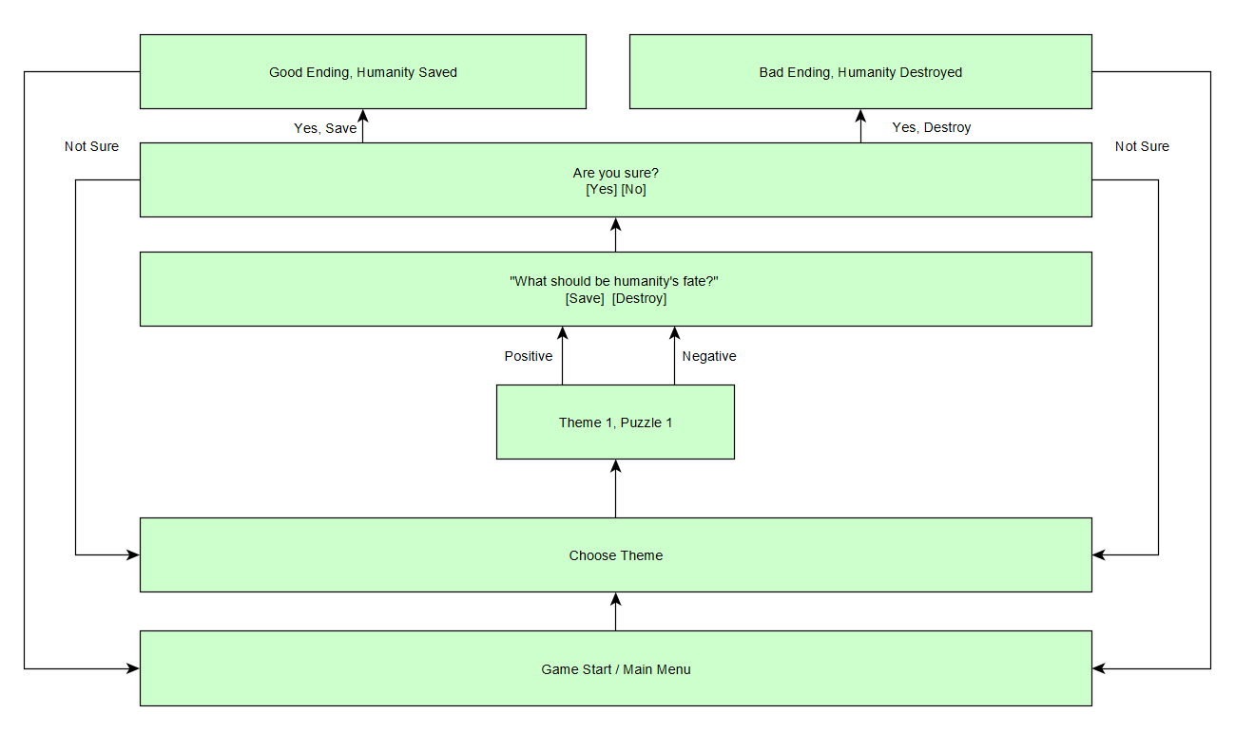

Takumi_panda Fast Text Storyboard (using Tenise idea) [please review]:

Start game ->

Fades from black (waking up) or slides bottom down while fading in.

Player (spirit) is facing F.A.T.E (Fully Artificial Thoughts Engine) in the starry black sky on a cloud.

F.A.T.E: Welcome player… You may have multiple questions. But can you answer my question first?

Player(spirit):

(Choice 1): Okay.

(Choice 2): NEVER! WHERE AM I? WHO ARE YOU?

*(Choice 2 chosen)*

F.A.T.E: You have failed humanity then…

*Bad Ending*

*(Choice 1 chosen)*

F.A.T.E: Here’s a thought…

Fades away and fades into a scene of displaying activist trying to stop lumberjacks cutting down trees

F.A.T.E: Who would you help here? The activists who are peacefully trying to stop the lumberjacks cutting down the environment or the lumberjacks who are helping a rural city that’s trying to expand for the future? Let me put you in their shoes…

F.A.T.E then transport the player into a body to control.

F.A.T.E: I gave you a temporary body to use. I cannot wait to see your results…

Player then has movement and moves through the puzzle as noted before.

*[So using tenise idea, the player can search for items in the area. For example to help the tree cutters, player can find a chainsaw, axe, and flannel. While if they want to help the activist, they find signs, paint, and tye dye shirt (sry if this sounds too stereotypical). They can pick up all 6 items and can choose either choice. If they missed an item, that choice is locked out and tells the player how many items they are missing for that certain choice and have a 3rd choice to walk away to continue searching for the items.]*

Player is teleported back to the starry black sky in front of F.A.T.E

(Activist Choice)

F.A.T.E: So you chose to help the activist. Are you happy with your choice?

Player (Spirit):

(Choice 1): Yes.

(Choice 2): No.

(Choice 2 chosen)

F.A.T.E: I shall give you another chance to choose then. Take your time and learn about your surroundings.

(Player is sent back to the puzzle (puzzle reset))

(Choice 1 chosen):

*Note: this will go to humanity save question since we only have one puzzle, once we have multiple puzzle, move to next puzzle)

F.A.T.E: What do you think of humanity? Are they savable or are they beyond repair?

(Choice 1): Yes.

(Choice 2): No.

(Choice 1):

F.A.T.E: This is your choice and your choice alone.

*Good ending*:

(Choice 2);

F.A.T.E: This is your choice and your choice alone.

*Bad ending*

Both have Comic book endings displaying the choices the player chose and the outcome of them. (Note: Text will describing the pictures since I don’t think we have a voice over)

(LumberJack Choice)

*similar to Activist, too lazy to write it all even though I could copy and paste it*

Need to go to both sides and see the conflict.

FATE is everywhere. Here’s a thought.

User Story Board:

<https://miro.com/app/board/uXjVN8sw380=/?share_link_id=164532081172>

**Scripts**

PlayerControls - Panda

* Vector3D MousePosition
* Functions:
  + Update
    - Is called every frame
    - **IFF** the Left mouse button is down:
      * Get the new mouse position
      * **Lerp** player to mouse position
        + Lerp docs: <https://docs.unity3d.com/ScriptReference/Vector3.Lerp.html>

FadeScript - Cep

* Float fadeSpeed
* Bool fadeDirection: In == 1 or Out == 0
* Functions:
  + FadeOut
    - Starts the process of changing the opacity.
    - Update loop applies the change.
  + FadeIn
    - Starts the process of changing the opacity.
    - Update loop applies the change.
  + FadeComplete
    - Returnsa bool if
  + Update
    - Is called every frame
    - Based on the fadeDirection
    - Skip when opacity is == 1 or 0 based on fadeDirection

GameScript - Bastien & Cep

* Enum GameState
* GameState CurrentGameState
* Functions:
  + Change State
    - Takes in a GameState
    - Transitions to another GameState
  + Update
    - Updates menu based on the current GameState
  + Enables and Disable Canvas groups
    - <https://docs.unity3d.com/Packages/com.unity.ugui@1.0/manual/class-CanvasGroup.html#:~:text=The%20Canvas%20Group%20can%20be,as%20well%20as%20all%20children>

Twinkle - **MotH**

* Takes two images of a star
  + Bright
  + Dim
* Make the bright star show on top of the dim
* Have the bright star enlarge and shrink
* Vars:
  + Max size
    - Limit to 2x the size of the gameObject
* Functions:
  + StartTwinkle
    - Starts the twinkle on process
  + StopTwinkle
    - Stops the twinkle process
  + Start
    - Random numbers for
      * Size of bright star
      * Delay of start
      * Lerp step
  + Update
    - Changes the size of the star

Animation - TEMP

* Controls the camera movement.

ScriptReader - TEMP

* Open a file, parse, and display text
  + JSON
  + Display in variable rate